 | 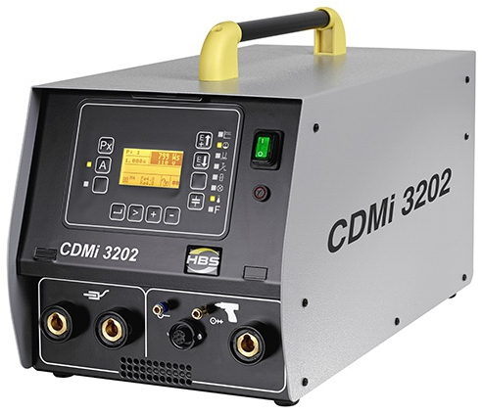 |  | Inverter-Capacitor  Charging Technology  Maximum welding rates  Minimum energy consumption  Minimum weight    Maximum efficiency
CDMi 3202

Stud Welding Unit
for CD stud welding (capacitor discharge welding)
according to current standards

Technical Data
Automation |  | Series
Welding range |  | #4 to 7/16", dia. 14 ga to 3/8”  M3 to M10, dia. 2 to 10 mm
Welding material |  | Mild steel, stainless steel, aluminum and brass
Welding rate |  | M3 = 43 studs/min. (Charging voltage 50 V)  M8 = 25 studs/min. (Charging voltage 140 V)  (M10 = 18 studs/min. (Charging voltage 200 V))
Capacitance |  | 132 000 µF/66 000 µF*
Welding time |  | 1 to 3 msec
Energy |  | 3 200 Ws/1 600 Ws*
Charging voltage |  | 50 to 220 V (stepless voltage regulation)
Primary power |  | 115 V/230 V, 50/60 Hz, 10 AT
Power source |  | Capacitor
Cooling type |  | F (temperature controlled cooling fan)
IP-Code |  | IP 21
Dimension L x W x H |  | 22.44" x 11.22" x 11.42" (570 x 285 x 290 mm) without handle
Weight |  | 59.53 lbs (27 kg)
 |  | * with change over of capacitors
Order No. |  | 92-12-23212B (Automation)
General Information
Application
- Especially suitable for thin sheets (at least 0.5 mm)
Process variants
- Contact welding
- Gap welding
Equipment
- Automation (series)
- Menu navigation in various languages: German, English, French, Italian, Russian, Portuguese, Spanish and Chinese

Advantages
Features
- Microcontroller – for precise process times, optimal functional reliability and maximum operating convenience
- Function monitoring – automatic function test following power-up; monitoring of all internal system functions
- Display of error codes – on LCD display
- Function control – All functions are visible on the operator panel via LED or display
Structure
- Compact
- Robust – metal housing withstands rough treatment in shop and on site
- Industrial plugs – standardised and sturdy plugs
- Two ground connections – direct coupling of several stud welding machines possible when installed in complex welding systems
Safety
- With integrated mains filter (protection against voltage peaks)
- Optimal for construction sites with large mains voltage fluctuations – use even with critical voltage supply (- 25 % + 20 %)
- Fulfils the requirements according to DIN EN 60974-10: 2008-09 - EMC test
- Fulfils the requirements according to DIN EN 60974-1: 2013-06 - Logged high voltage test
- Logged capacitor forming for quality control of the stud welding capacitors
- Controlled capacitor forming – step-by-step charging of capacitors after long standstill times for longer service life of capacitors
- Retriggering lock-out – prevents welding on a welding element that has already been welded
- Thermal control of inverter-capacitor charging unit and internal temperature of stud welding unit– automatic switch-off in the event of overheating
- Temperature controlled cooling fan – reduces noise and dust in the stud welding unit (greater system reliability)
- Control unit galvanically separated from welding lines – high degree of functional safety
- Optimal cooling air stream – protection of the electronic components against contamination and ideal cooling of the inverter-capacitor charging circuit board for high cycle sequences
- Shock-resistant operation panel – operation panel protected by protruding casing
- Shock-resistant capacitors – capacitors protected by shock proofing elements
- Accessory: Control guard made of acrylic glass (lockable) – prevents damage and unauthorised access
Welding
- Graphic display – clear operator guidance via large LCD display
- Setting of charging voltage in V and charging energy in Ws – when changing the charging voltage, the charging energy is automatically adjusted
- Process sequence control – detection and evaluation of influencing variables of the welding process via the process control (CP); after every welding, a comparison of the reference CP value and the actual values is performed; display of the actual and target value; welding stop when limit values are exceeded can be activated; limit values can be selected in steps; manual entry of CP value possible
- 15 programs can be stored – in every program, the parameters (charging voltage, capacity, CP settings and automatic settings) can be selected digitally via a superior control system and specific to the application
- Remote control of the stud welding machines via standardised RS232 interface possible – the stud welding machines can be controlled directly via the PC or CNC welding systems
- Library function – library with stored welding parameters for different diameter and material combinations for a quick start of the welding process
- User-specific settings– weld counter (display of previously executed welds); menu navigation in various languages; units (metric, imperial); date; time; setting of the transmission rate of the interfaces

- Gun / welding head test – functionality check of the welding guns or the welding heads with a lifting test (check of the lifting function of the gap welding guns and bolt welding heads without contact with the workpiece); functionality check of the welding guns or the welding heads by recording the movement time of the solenoid from triggering to the contact with the workpiece
- Reading out of CP values via standardised RS232 interface – for the output of data such as the date, time and welding parameters of each weld with the superior control system; welding parameters of every weld are logged
- Powerful – built-in power reserves
- Inverter-capacitor charging technology – makes high cycle rates possible
- Trouble-free changing of welding voltage polarity possible by reconnecting welding current and ground cables
- Use of special capacitors (developed for stud welding)
- Capacitance switching – 66 000 µF or 132 000 µF
Suitable stud welding guns/ heads
- C 08
- CA 08
- PAH-1
- KAH 412
- KAH 412 LA
Issue 05/15
(Technical data may change)

